

TEAM STRUCTURE

TEAM 2



October 23, 2014

tEAM 2

Newcastle University

Contents

Team Members 1

Roles 2

The Agile Process 4

Agile Team Rules 6

# Team Members

SCRUM Master/Designer **– Matthew Selby (Student No. 130545637)** (Team Leader)

Product Owner/UI Designer - **Joshua Greenwood (Student No. 130334835)** (Deputy Team Leader)

Programmer/System Designer/Tester - **Deniz Kucukterzi (130427355)**

Programmer/System Designer/Tester - **Daniel Baranowski (130116389)**

Programmer /Tester - **Daniel Smith (130283555)**

Programmer/Tester - **Mikey Edwards (130265160)**

Programmer/Tester - **Oliver McPheely (130169639)**

UI Designer/Documenter - **Jack Hookham (130220169)**

# Roles

The team will consist of several different roles. These roles are flexible; any person can take on one or more roles at any particular time, should it be necessarily.

The following outlines what each of the roles will involve within this agile team:

#### SCRUM Master – Matthew Selby

Ensure that the agile process runs smoothly by protecting the team from disruptions and impediments.

Organise meetings including sprint planning, daily scrum (over a social networking website as it is not always feasible to do this face-to-face) and sprint retrospectives. Document the outcomes of these meetings.

To motivate and keep a high team morale.

Maintain high team efficiency and creativity.

#### Product Owner – Joshua Greenwood

Responsible for creating and maintaining the backlog

Prioritising the backlog

Ensures that quality work is produced by accepting or rejecting the work produced by the development team

Development Team

All team members are in the development team. The development team is made up of the system designers, UI designers, programmers, testers and documenters:

**System designers** will design the architecture of the system. They decide how the separate components of the system will work together. They will be directed by members of the group who have declared system design as a personal strength.

**UI designers** will design the look and feel of the system.

**Lead designer –** A Lead Designer will be decided by consensus on who fits the role the most, by the team after gaining some experience designing together. If the consensus is split, the project leader will make the tiebreaking decision.

**Programmers** will implement the system using the designs produced by the system designers. They will also integrate the UI design produced by the UI designers into the system.

**Lead Programmer –** A Lead Programmer will be decided by consensus on who fits the role the most after gaining some experience programming together. If the consensus is split, the project leader will make the tiebreaking decision.

**Testers** will write and execute automated non-functional testing to ensure the system is behaving correctly and meets the requirements. Testing also includes installation, compatibility, regression, smoke and acceptance testing. All team members take part in manual, functional testing.

**Documenters** will document the user manual of the system. They will also document the system manual for the current programmers and any future programmers who join the team at a later time.

# The Agile Process

We have chosen the Agile SCRUM approach to the project. We decided on this method due to its flexible nature and its ease of implementation. We will use the JIRA agile project management software to track project status and record bugs. The following gives a brief overview of the process we have decided execute.

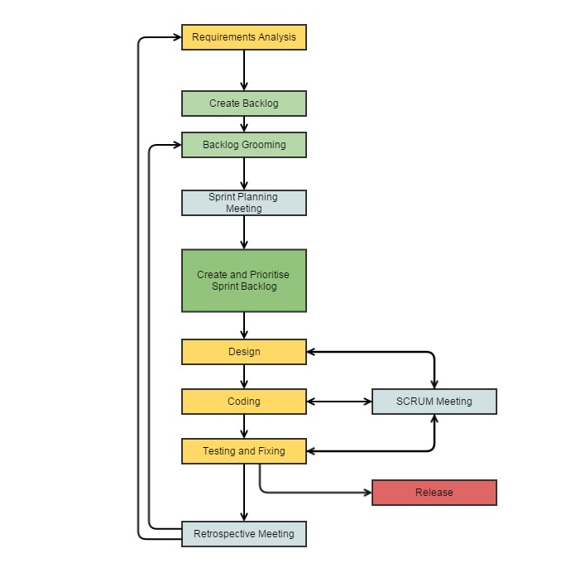

Diagram showing our agile process. (Created by the team programmer 20/10/2014)

#### Requirements Analysis

The entire team will study the brief and any other resources provided by the customer. If required, we will get in touch with the customer for any clarification. We will use this information to establish a clear set of requirements. At the same time we will be researching on the best methods to implement the solution.

#### Create Backlog

Once we have the requirements, the product owner will create the user stories and their sub-tasks.

#### Backlog Grooming

After some lengthy discussions with the team, the product owner will prioritise user stories and estimate the time required for each user story and sub task. After the first iteration, backlog grooming may involve the removal or adjustment of user stories.

#### Sprint Planning Meeting

A meeting to discuss the user stories to include in the next iteration will be arranged by the SCRUM master.

#### Create and Prioritise Sprint Backlog

After the meeting, the user stories for the next iteration will be assigned in JIRA. These should then appear in the SCRUM task board.

#### SCRUM Meetings

Frequent SCRUM meetings will take place to check on the progress of every member in the team. Members will discuss what they have accomplished, what they are currently working on and any impediments or difficulties they are having. This is to ensure that we are all on the right track and anyone who needs support can receive it. This should take place at least 3 times a week.

#### Design

System and UI design will take place here for the user stories selected for the sprint.

#### Coding

The programmers will look at the list of tasks on the SCRUM board and assign themselves a task of their choice. They must update the board once they have completed a task.

#### Testing and Fixing

Testers will begin testing the product by using either new or already written automated tests. Functional testing will take place at the same time. All bugs will be recorded in JIRA. Testers will record the bugs and inform the programmers. Once the programmers have fixed the bugs, the testers will double check this and close the bug tickets before signing off QA.

#### Retrospective Meeting

Once the sprint has ended, the team will get together and discuss the positives and negatives of the sprint. They will also discuss how they can improve themselves for future iterations.

#### Release

A copy of the released product for that sprint will be made and saved. A new sprint can then begin either with or without adding any new features to the product backlog.

# 

# Agile Team Rules

1. Must deliver working software frequently (every sprint should last 3 weeks);
2. All sprints will be “time-boxed” so although the features included in a sprint may change, the time spent on a sprint will always remain the same;
3. Must accept that requirements may change during development and prepare for these changes;
4. Give team members all the support they need and trust them to get the job done;
5. Must have face-to-face conversation as often as possible from start to finish of the project;
6. The team must work at a constant pace indefinitely to ensure they keep to the sprint deadlines;
7. Must give special attention to UI and technical design and aim for a product as close to “perfect” as possible;
8. The team must be self-organising, so that if there is a moment of disorder such as a shortage of testers, then members in other roles can reorganise themselves to help with testing;
9. Must learn from previous sprints on how to work better as a team and implement that new knowledge in future sprints.

Word Count for Structure: 1143

Word count for Contract and Structure combined: 2233 words.